**README |** Grazioso Salvare Rescue Dog Dashboard  
Kristina Dudeck

**Project Overview and Required Functionality**

This project delivers an interactive web application dashboard for **Grazioso Salvare**, an international rescue-animal training company. The dashboard enables users to filter and analyze real-time animal shelter data sourced from the Austin Animal Center in order to identify dogs suitable for various types of search-and-rescue training.

The dashboard performs the following required functions:

* Displays a **Grazioso Salvare logo** that links to [www.snhu.edu](https://www.snhu.edu/) and includes **credit to the creator**.
* Provides **interactive filter options** via a dropdown menu and reset button that allow users to view dogs based on the following rescue types:
  + **Water Rescue**
  + **Mountain or Wilderness Rescue**
  + **Disaster or Individual Tracking**
  + **Reset** (returns the dashboard to its unfiltered state)
* Updates a **data table** to show results from the selected filter
* Dynamically updates a **pie chart** to display the distribution of dog breeds
* Dynamically updates a **geolocation map** to display the location of selected dogs\

**Screenshots of Functionality**

The following screenshots demonstrate that the dashboard meets the specified functionality. Each includes the Grazioso Salvare logo:

1. **Initial Dashboard (Unfiltered State)**  
   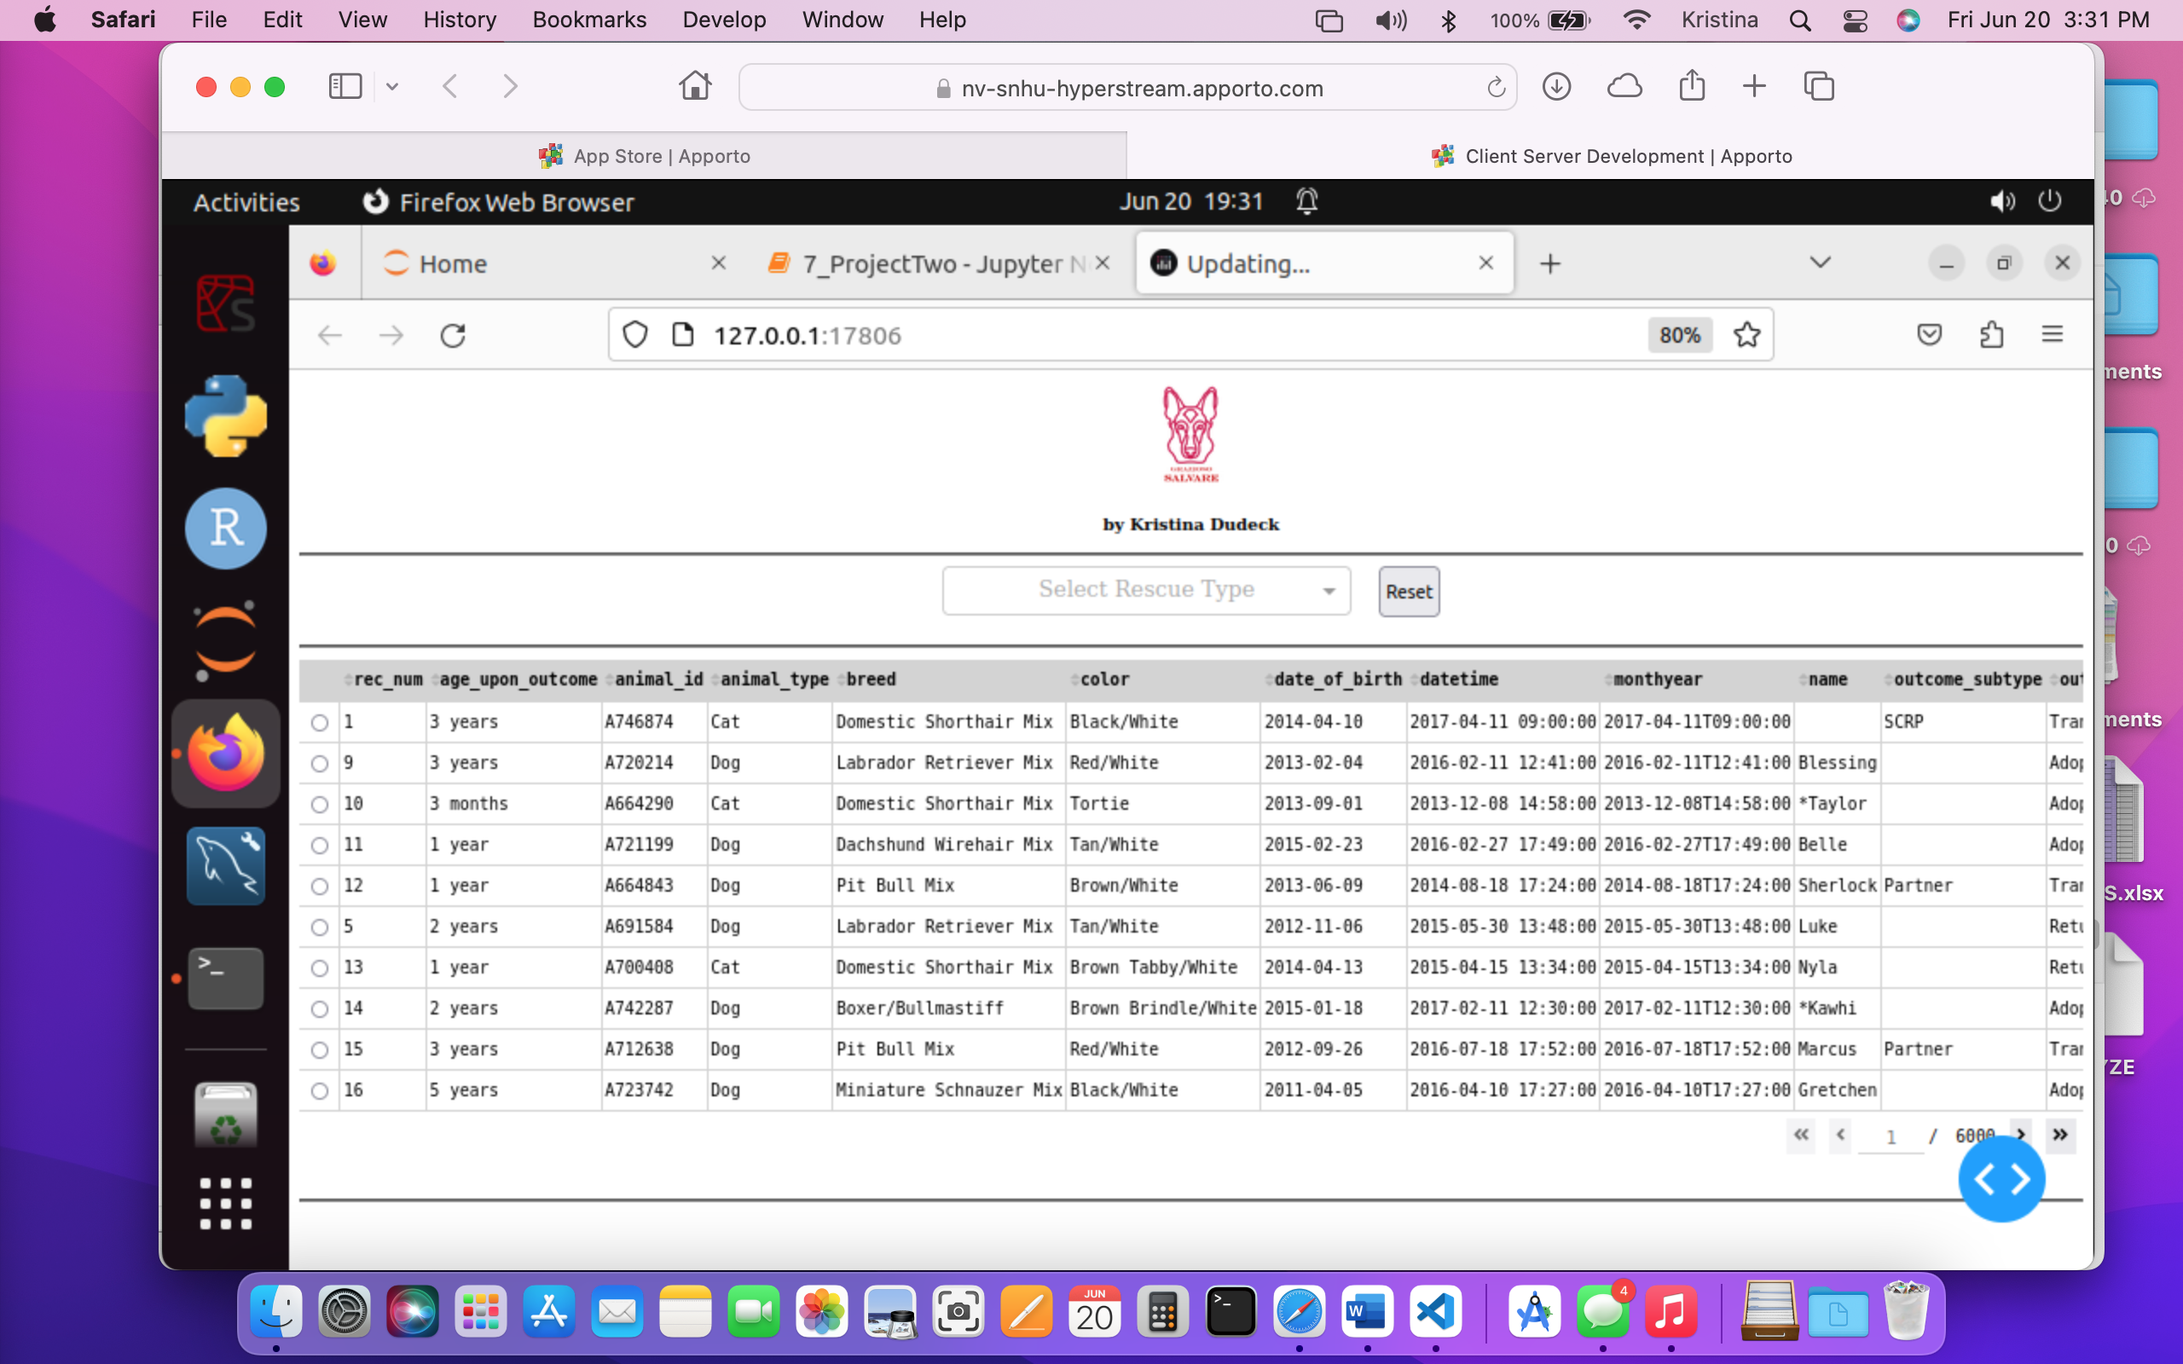
2. **Water Rescue Filter Applied**  
   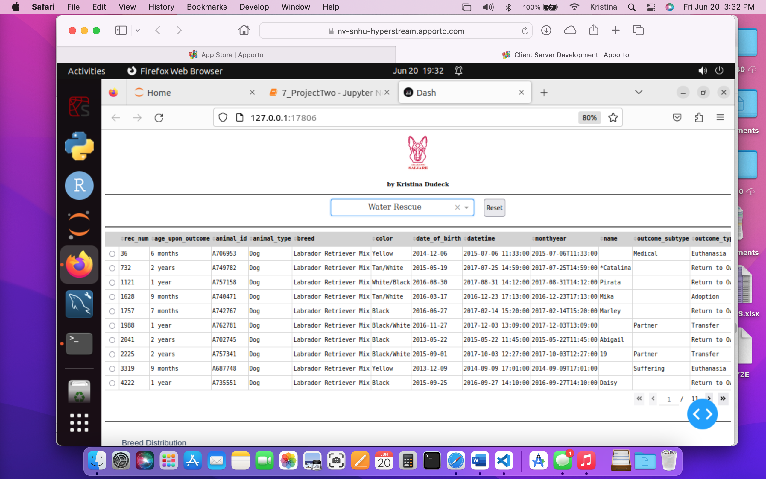
3. **Mountain or Wilderness Rescue Filter Applied**  
   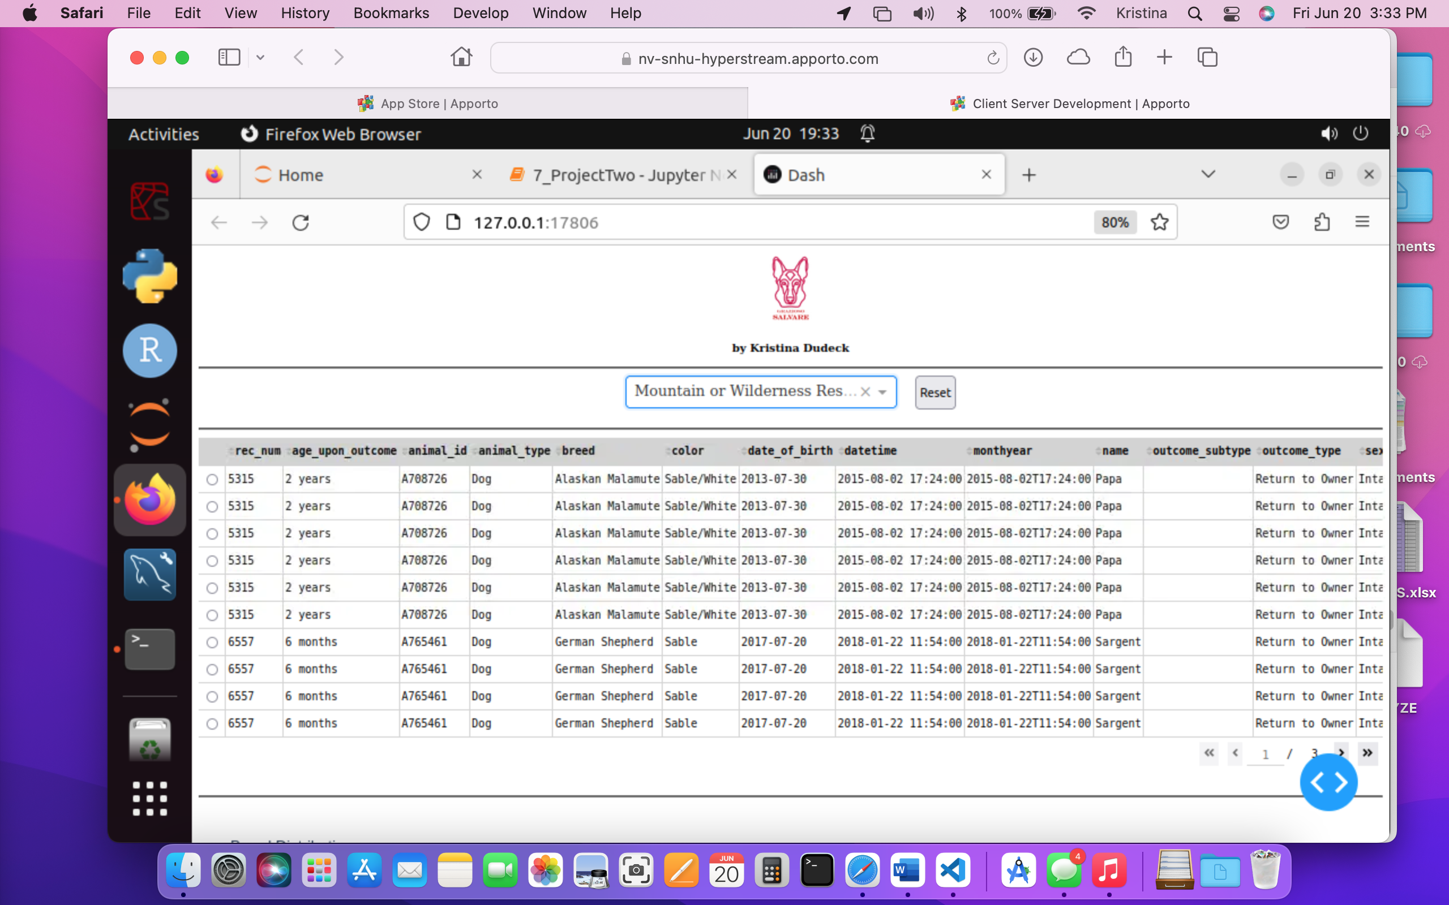
4. **Disaster or Individual Tracking Filter Applied**  
   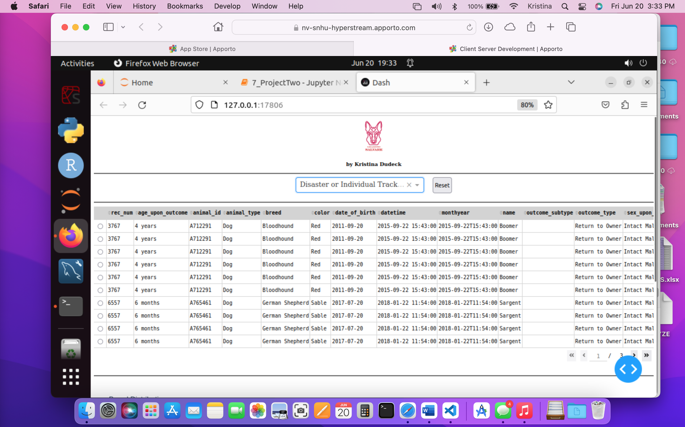
5. **After Clicking Reset Button**  
   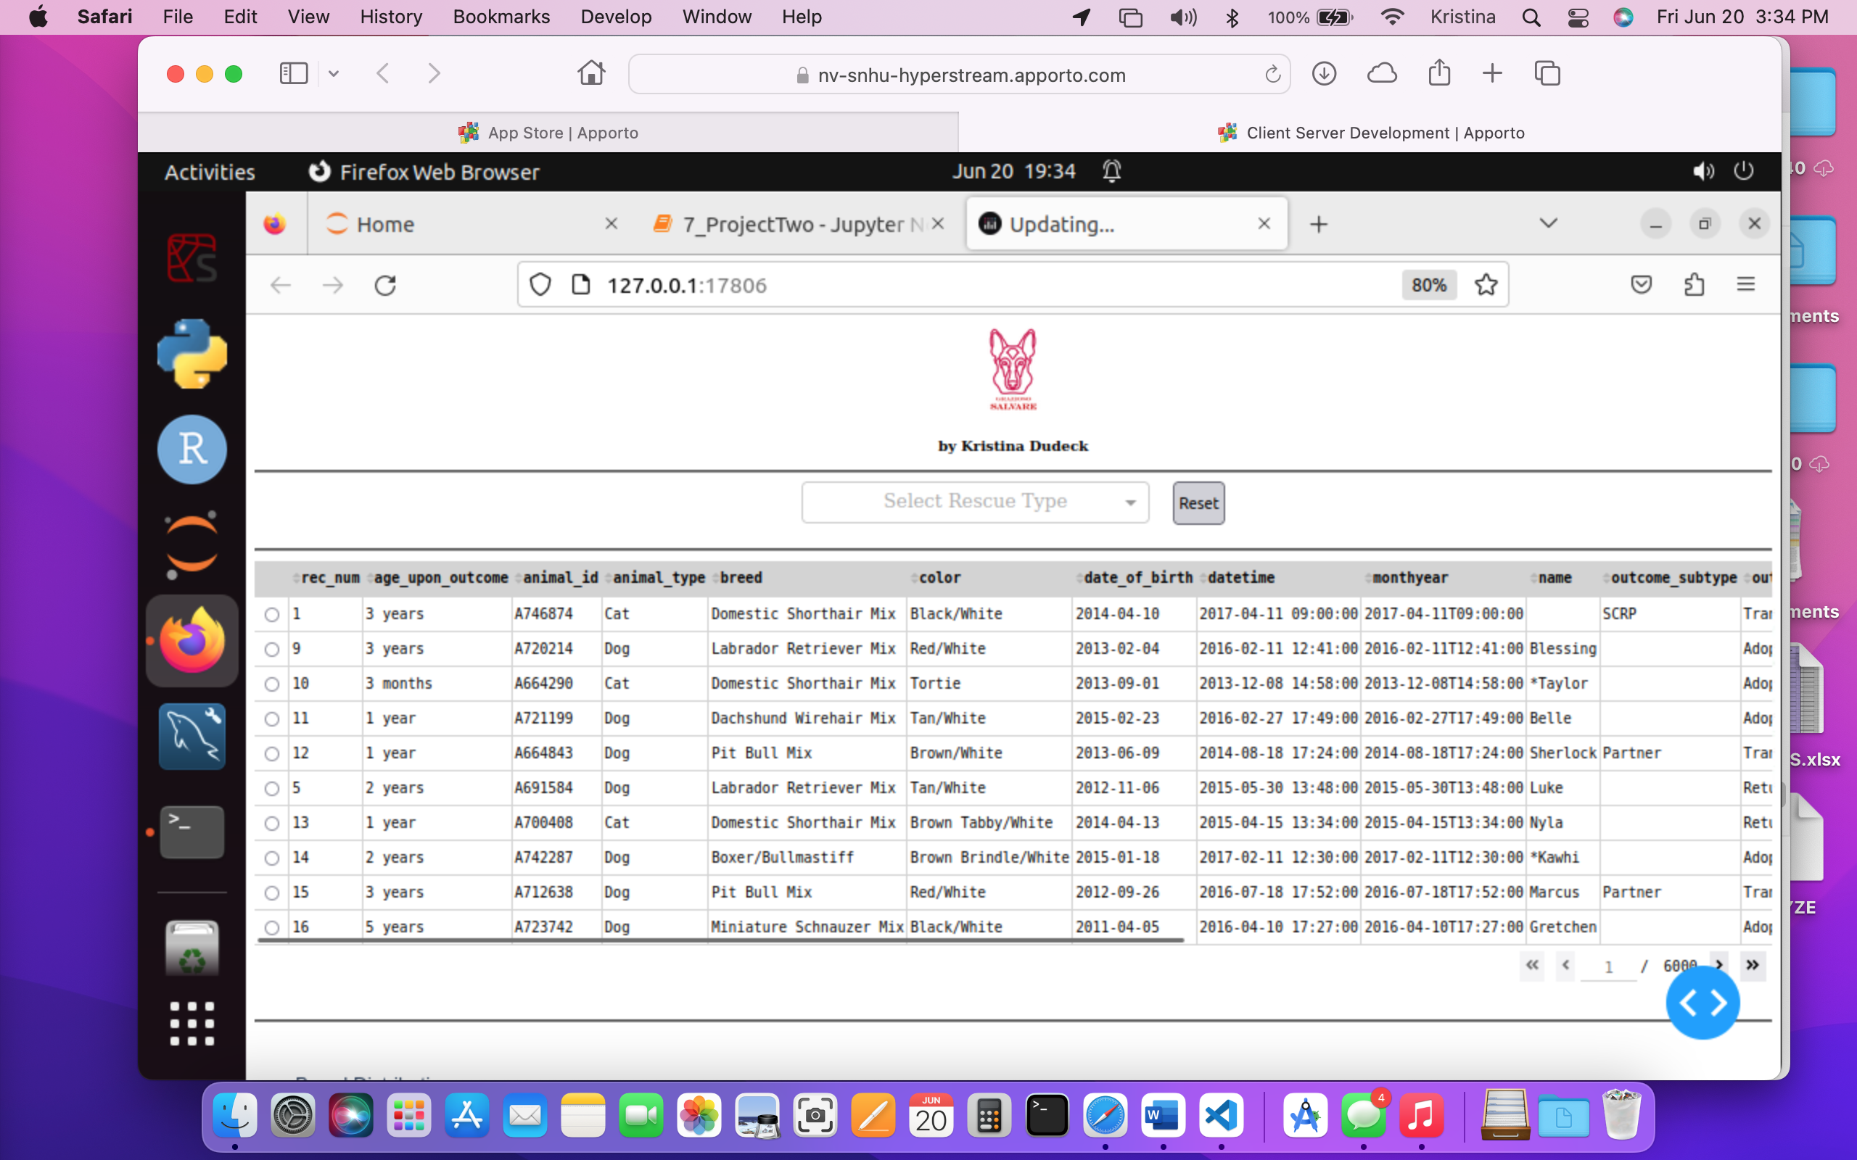
6. **Dashboard widgets:**  
   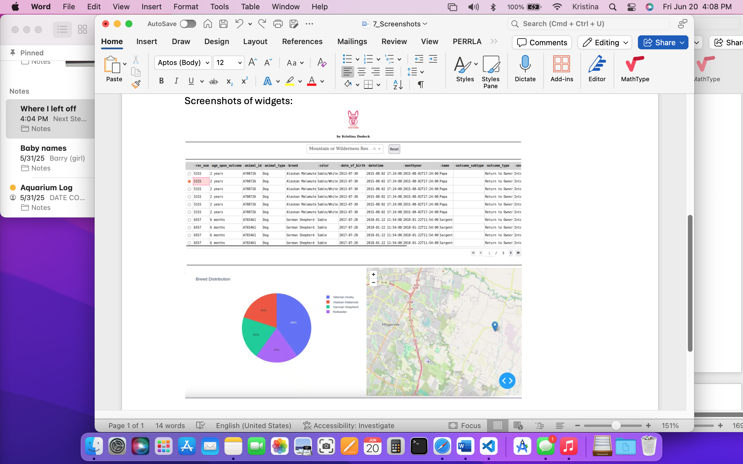

**Tools and Technologies Used**

**MongoDB (Model)**

MongoDB was chosen for this project because it is a flexible, document-oriented NoSQL database that pairs well with Python and JSON-style data. MongoDB’s powerful query capabilities made it ideal for filtering animals based on breed, age, and sex. Additionally, MongoDB integrates easily with Python via the pymongo library, allowing for rapid development and dynamic data retrieval.

**Python + Dash (Controller & View)**

* **Python** served as the core development language for both the backend database interface and the front-end logic.
* **Dash**, a framework built on Flask, Plotly, and React, was used to create a responsive web interface. Dash allows developers to construct visual components like charts and tables declaratively in Python while supporting interactive callbacks.
* **Dash Leaflet** was used to embed a geolocation map that can show markers based on latitude and longitude.
* **Plotly Express** was used to generate the interactive pie chart for breed distribution.

**JupyterDash**

This variation of Dash allows the dashboard to run inside a Jupyter Notebook, which is suitable for demonstration and educational purposes.

**Resources and References  
T**he following tools, libraries, and guides were used to support the development of this project:

* [MongoDB Documentation](https://www.mongodb.com/docs/)
* [pymongo Library](https://pymongo.readthedocs.io/en/stable/)
* [Dash Documentation](https://dash.plotly.com/)
* [Dash Core Components](https://dash.plotly.com/dash-core-components)
* [Dash HTML Components](https://dash.plotly.com/dash-html-components)
* [Dash Leaflet](https://dash-leaflet.herokuapp.com/)
* [Plotly Express](https://plotly.com/python/plotly-express/)
* [JupyterDash](https://github.com/plotly/jupyter-dash)

**Steps to Reproduce the Project**

1. **Prerequisites:** Ensure the following are installed in your environment:
   * Python 3.7+
   * MongoDB (running locally or accessible remotely)
   * Jupyter Notebook or JupyterLab
   * The following Python packages:  
     pip install dash dash-leaflet jupyter-dash pandas plotly pymongo
2. **Project Setup:**Set up your project directory with the following essential components:
   * **A Jupyter Notebook file** (e.g., dashboard.ipynb) to serve as your main dashboard application
   * **A Python module** (e.g., crud.py) that defines the AnimalShelter class and implements basic CRUD operations to connect to your MongoDB database
   * **A logo image** (e.g., GS_Logo.png) for branding, which will be displayed in the dashboard header

Ensure your MongoDB collection is pr4eloaded with the Austin Animal Center Outcomes dataset, including fields like:

* breed, sex_upon_outcome, age_upon_outcome_in_weeks, location_lat, location_long, etc.

Update your CRUD connection string with your own MongoDB credentials (for example, username aacuser and appropriate password).

1. **Create the Dashboard Interface**In your Jupyter Notebook file:
   * Import necessary modules (dash, dash_table, plotly.express, dash_leaflet, pandas, etc.)
   * Build a user interface layout that includes:
     1. A header with a logo and author credit
     2. An interactive dropdown menu for filtering rescue types
     3. A reset button to clear all filters
     4. A data table that updates based on user input
     5. A pie chart or other chart to visualize breed distributions
     6. A map to show dog locations using latitude and longitude
   * Create Dash callbacks that connect user ineteractions to data updates in the charts and table
2. **Run the Dashboard**To launch the dashboard:
   * Open your notebook in Jupyter
   * Run all cells
   * The JupyterDash app will open either inline or in a browser window
   * Use the dropdown and reset button to interact with the dataset
3. **Test and Verify**  
   Make sure the dashboard behaves as expected:
   * Filters return correct results for:
     1. Water Rescue
     2. Mountain or Wilderness Rescue
     3. Disaster or Individual Tracking
   * All visual elements update in response to their filter selection
   * Resetting restores the original full database
   * Charts and maps reflect the current data state

**Filter Query Logic**Each filter option runs a MongoDB query based on the following rescue criteria:

| **Rescue Type** | **Breeds** | **Sex** | **Age Range** | |
| --- | --- | --- | --- | --- |
| **Water Rescue** | Labrador Retriever Mix, Chesapeake Bay Retriever, Newfoundland | Intact Female | 26 – 156 weeks |
| **Mountain/ Wilderness** | German Shepherd, Alaskan Malamute, Old English Sheepdog, Siberian Husky, Rottweiler | Intact Male | 26 – 156 weeks |
| **Disaster/ Tracking** | Doberman Pinscher, German Shepherd, Golden Retriever, Bloodhound, Rottweiler | Intact Male | 20 – 300 weeks |

**Development Process & Challenges**

**Development Steps**

* Connected to MongoDB via crud.py using authentication
* Queried shelter data and loaded it into a pandas DataFrame
* Built the dashboard layout in Dash, including:
  + Dropdown menu for filters
  + Reset button
  + Interactive data table
  + Geolocation chart
  + Breed pie chart
* Implemented callback logic to dynamically update dashboard components based on user input

**Challenges and How They Were Resolved**

**Challenge:** The pie chart displayed skewed when data was missing  
**Solution:** Added conditional logic to check for empty or missing breed column before rendering

**Challenge:** The map did not display when no row was selected  
**Solution:** Added default map center on Austin, TX and used row index logic to display a marker only if a row is selected

**Challenge:** Resetting the dashboard state  
**Solution:** Used a combination of n_clicks and custom callbacks to ensure that reset behavior was consistent across all widgets

**Challenge:** Dropdown and button misaligned  
**Solution:** Used inline-block layout styling and fixed component height to visually align controls

**Conclusion**

This project showcases how full-stack development principles can be used to build an intuitive and functional dashboard interface. The tools and framework choices enabled rapid development, while MongoDB’s flexibility allowed for precise, real-time data filtering. The final product fulfills all client requirements and provides Grazioso Salvare with a useful tool for identifying dogs suitable for search-and-rescue training.

**Contact**Kristina Dudeck